

Lux Residential Warranty Program
Builder User Guide
-DRAFT-

Introduction

Lux Residential Warranty Program Inc. is opening its management system for our builder partners.

This management system will allow you to manage all the billing process on our website.

This includes managing your invoices online, pay online or by cheque and view your payment history.

In the near future you will also be able to manage your contact information and Warranty Programs.

How to log in

You can access the login page from the Lux Residential Warranty Program Inc. home page menu.

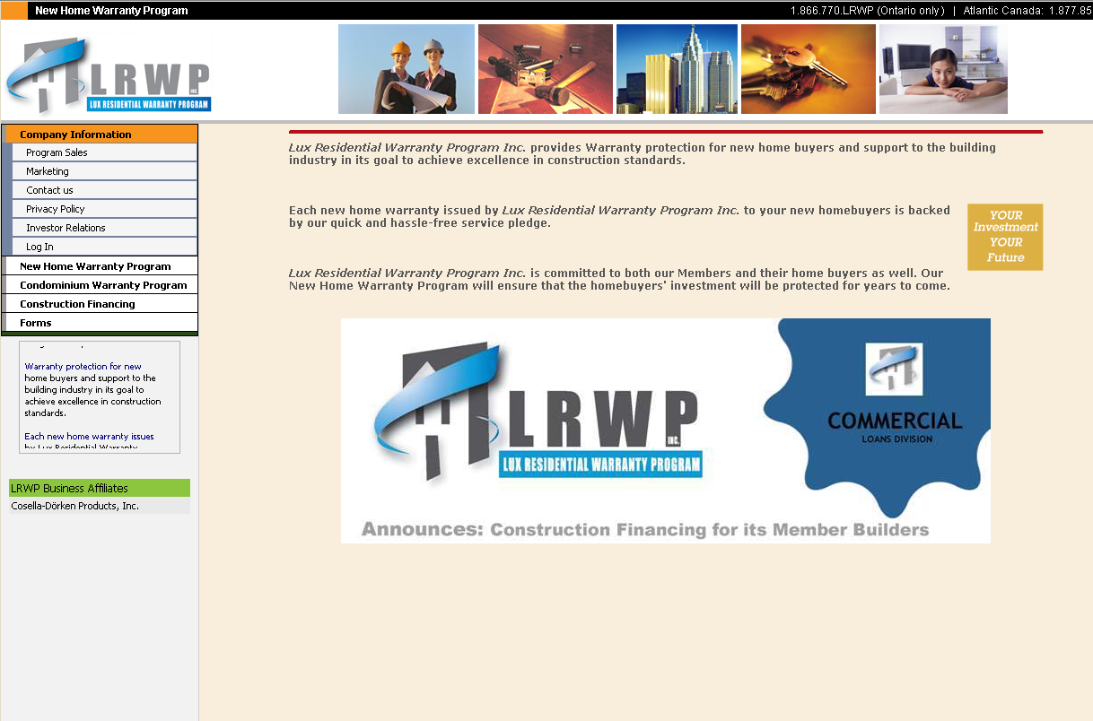

You just have to click on the “Log in” item.

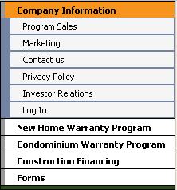

You will then see the following page.

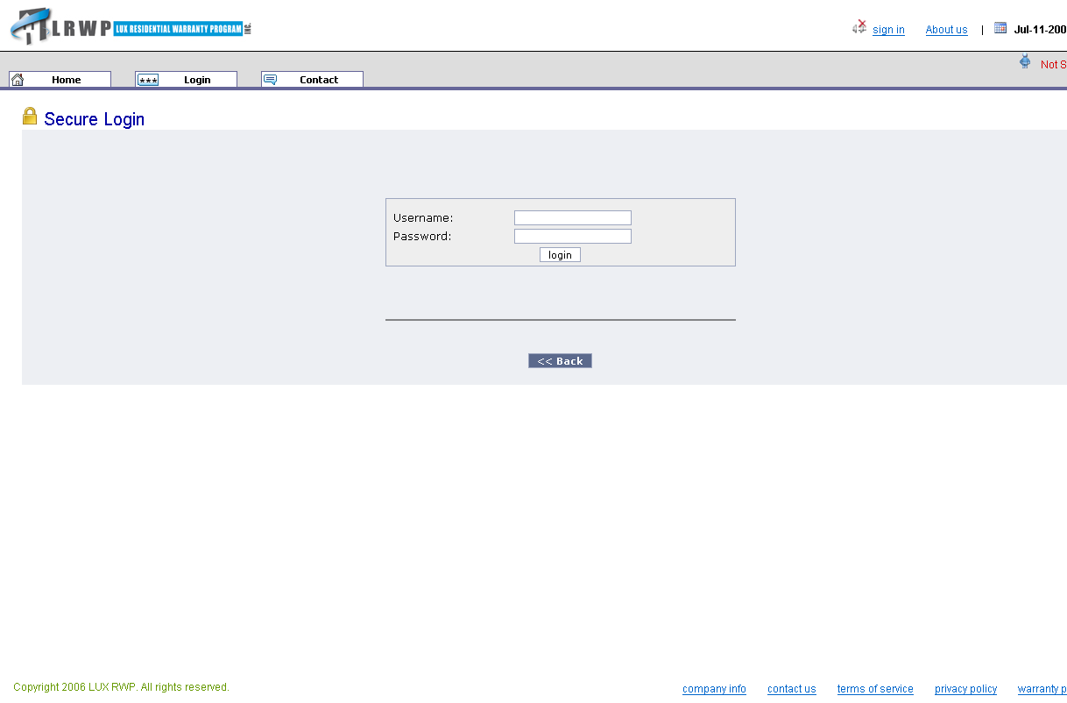

You just have to input your username and password and click on the “login” button.

Your user name is your LRWP registration.
Your password is “p455” + your LRWP registration number.

Example:

Username: CAQC0001
Password: p455CAQC0001

If you entered a valid user name and password you will see this page:

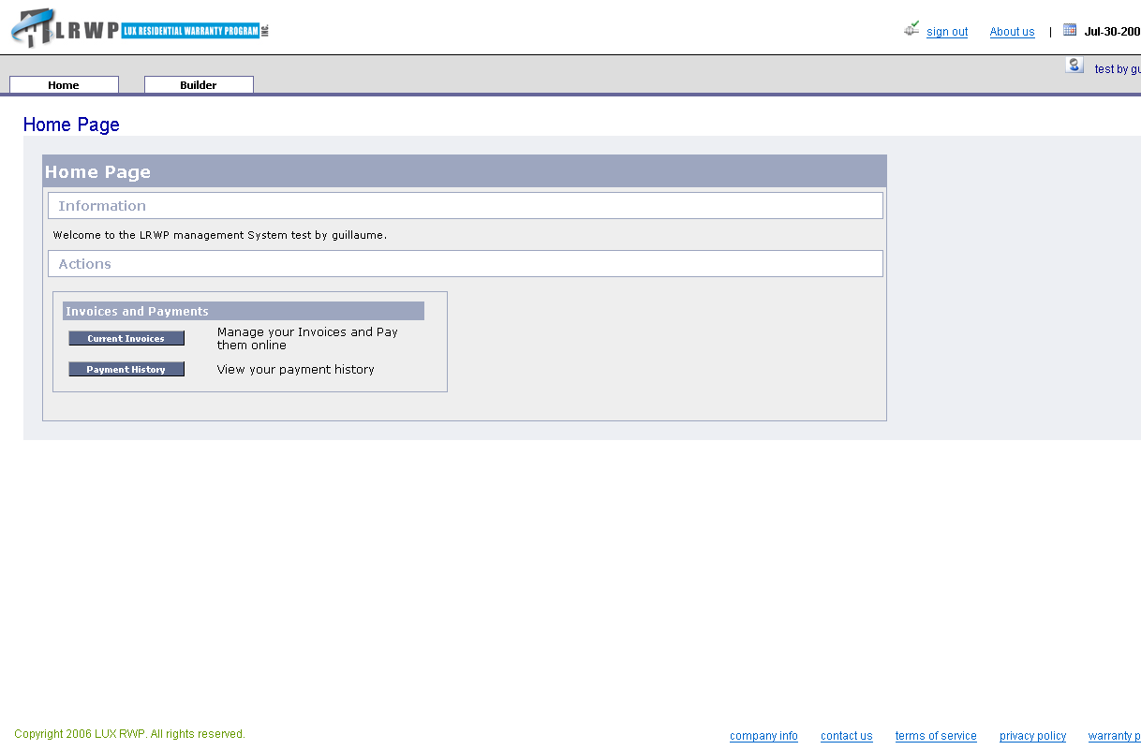

How to pay your invoices online

You have to login to be able to pay your invoices online.
Once you have successfully log into the system you will see the following page:

Then you have to click on the “Current Invoices” button:

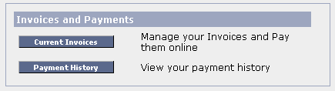

You will then be redirected to the Current Invoices page.
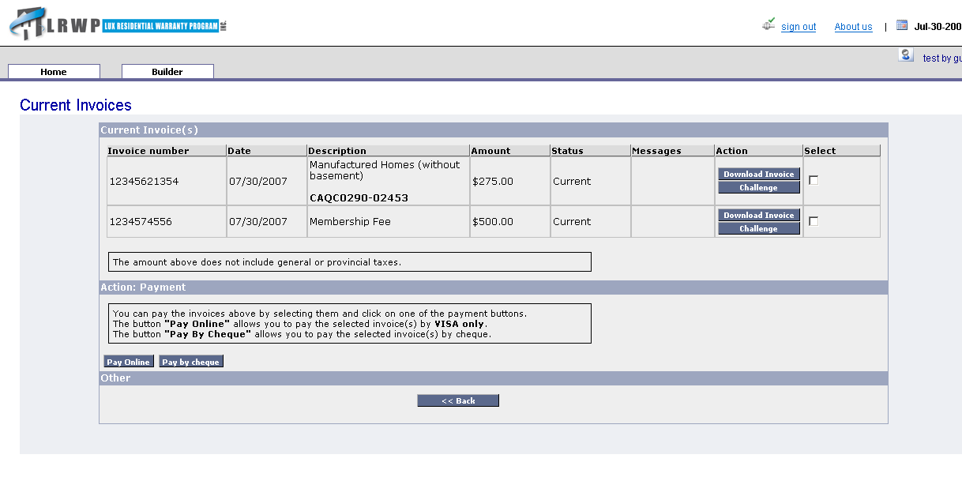

This page presents your current invoices.

You have to select the invoice(s) you want to pay by clicking on the check box in the right most column.

When you are satisfied with your selection you can click on the “Pay Online” button.

You will be redirected to the following page:

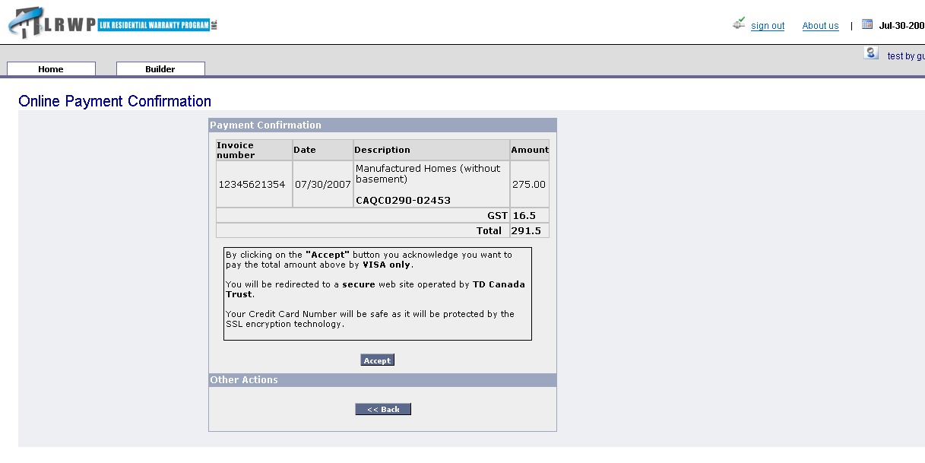

This page invites you to confirm your choice. You can see the selected invoices and the total amount to be paid (Sales Taxes included).

If you are ready to pay, please click on the “Accept” button.

You will then access a TD Canada Trust page. It is entirely secure. You can input your card number in confidence.

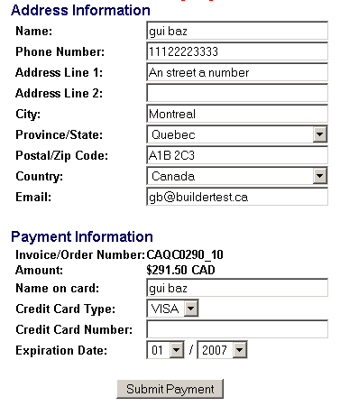

After inputting all you address and payment information you can click on the “Submit Payment” button.

If the bank accepts the payment you will see the following page.

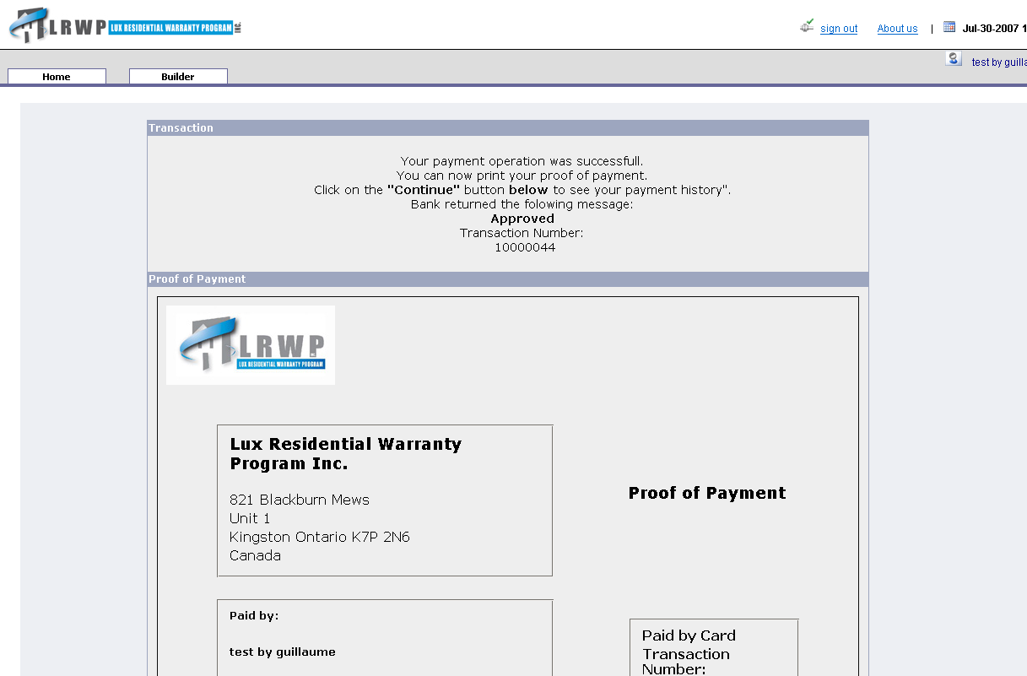
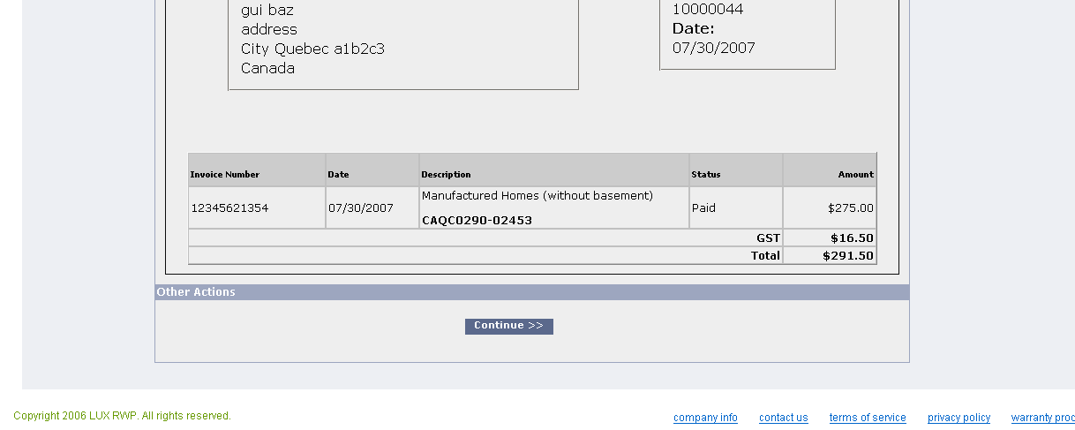

This page assert you have successfully paid your invoice(s).
You can click on “Continue” to see your payment history.

How to pay by cheque

The process is almost the same as for paying online.

You have to login to be able to pay your invoices online.
Once you have successfully log into the system you will see the following page:

Then you have to click on the “Current Invoices” button:

You will then be redirected to the Current Invoices page.

This page presents your current invoices.

You have to select the invoice(s) you want to pay by clicking on the check box in the right most column.

When you are satisfied with your selection you can click on the “Pay Online” button.

You will be redirected to the following page:

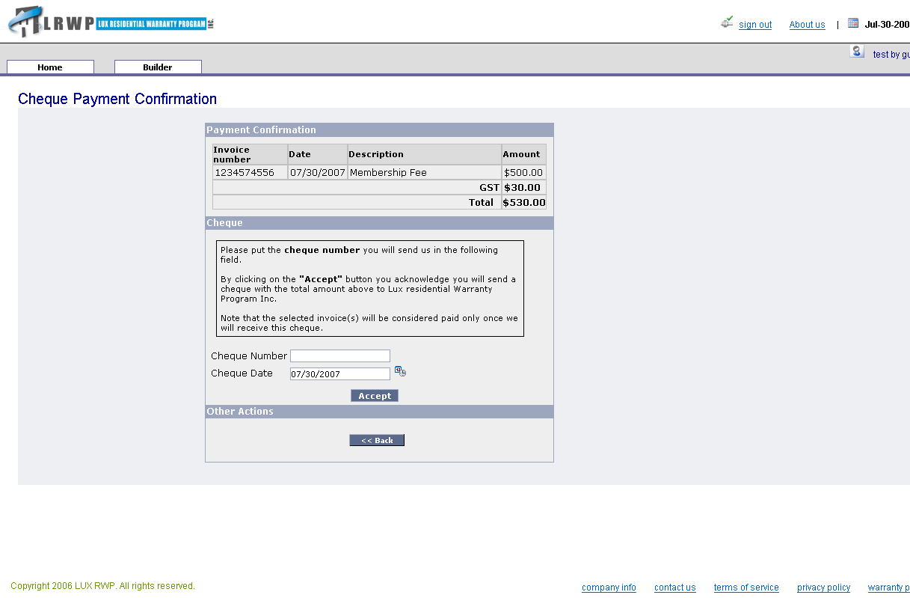

This page ask you to confirm you will pay the selected invoice(s) by cheque and ask you for the cheque number you will send us.

Once you have filled a cheque and written its number in the “Cheque number field” you can click on the accept button.

You will be redirected to the “Payment History” page:

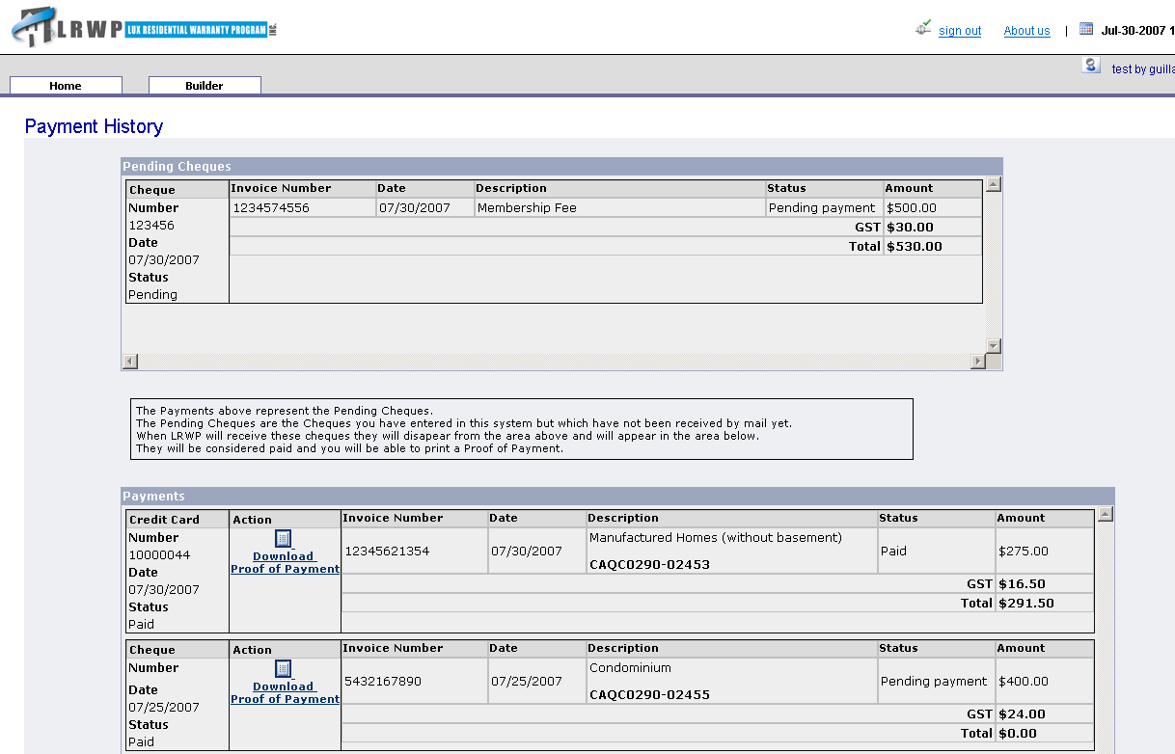

Your “cheque” is visible in the pending cheque area. It will stay there as long we do not receive your cheque.

Other

If you need more detail you can refer to the next section of this document: Page description.
It gives an in depth description of each page.

Pages description

Home Page

This page is your home page which gives you some information and shows what actions you can do on the system.

This is your main page which allows you to navigate in the system. It is composed of action panels which aggregates related features.

The “Invoices and Payments” action panel gives you the choice between two actions:

- Current Invoices
  - Redirects you to the Current Invoices Page.
- Payment History
  - Redirects you to the Payment History Page.

Current Invoices Page

This page shows your current Invoices. It will help you understand what you have to pay.

Page detail:

This page shows a table with each rows being an Invoice.
For each invoice you have the following information:

- Invoice number
  - The unique invoice number
- Date
  - The invoice issuing date.
- Description
  - An extensive description of what the invoice is about.
- Amount
  - The definitive invoice amount (not including sales taxes)
- Message
  - You can see here the messages about an invoice you have challenged.
  - When there is more than one message you can click on the “More” button to see the complete dialogue.
- Status
  - The invoice status:
    - Current
    - Past Due if 30 days or more have elapsed since the invoice issuing date. In that case the invoice background becomes red.

- Action
  - The button “Download Invoice” allows you to view and print the invoice.
  - The button “Challenge” allows you to send a message about an invoice to LRWP. You will be redirected to the Dialogue Board Page.
- Select
  - The check box to select an invoice. (you can select more than one)

Possible Actions:

You can select one several invoice(s) and do the following actions:

- Pay Online
  - Redirects you to the Card Payment Confirmation Page
- Pay By Cheque
  - Redirects you to the Cheque Payment Confirmation Page

Cheque Payment Confirmation

This is the page you see after having selecting some Invoices and click on the “Pay by Cheque” button.
It allows you to confirm you will pay the selected invoices by sending a cheque to Lux Residential Warranty Program.

Page detail:

At the top of the page you can see a table with invoices you have selected.
For each invoice you have the following information:

- Invoice number
  - The unique invoice number
- Date
  - The invoice issuing date.
- Description
  - An extensive description of what the invoice is about.
- Amount
  - The definitive invoice amount (not including sales taxes)

You can also see the total sales tax amount and the total payment amount.

At the middle of the page the “Cheque” panel will allow you to input the cheque number you will send to Lux Residential Warranty Program.

You can also change the cheque date if you wish to send it later by clicking on the calendar icon.

Possible Actions:

You can select one several invoice(s) and do the following actions:

- Accept
  - The button “Accept” allows you to accept the payment conditions.
  - Not that you must input the cheque number before clicking on “Accept”
  - You will be redirected to the Payment History Page
- Back
  - The button “Back” allows you to cancel the payment.
  - You will be redirected to the Current Invoices Page.

Card Payment Confirmation Page

This page shows the invoices you have selected and confirm you want to pay them online.

Page detail:

At the top of the page you can see a table with invoices you have selected.
For each invoice you have the following information:

- Invoice number
  - The unique invoice number
- Date
  - The invoice issuing date.
- Description
  - An extensive description of what the invoice is about.
- Amount
  - The definitive invoice amount (not including sales taxes)

You can also see the total sales tax amount and the total payment amount.

Possible Actions:

- Accept
  - The button “Accept” allows you to accept the payment conditions.
  - Once you have clicked on this button you will not be able to go back.
  - You will be redirected to the Bank Payment page.
- Back
  - Cancel the payment. You will be redirected to the Current Invoices Page.

Bank Payment Page

This page is operated by TD Canada Trust. It is a secured page which means you can input your credit card number in confidence.
Lux Residential Warranty Program will not be able to see or store your credit card information.

Page detail:

Some of the fields are already filled with the data we have in our database.
Make sure they are accurate and match the one associated with your credit card.

Possible Actions:

Once the address information and payment information are correct you are redirected to the Card Payment Result Page.

Card Payment Result Page

Error page

If your payment has not been accepted by the bank you will see this page.

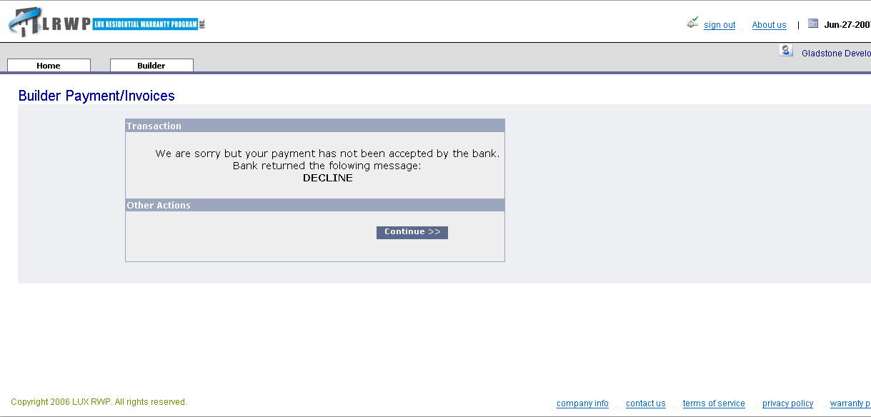

Page detail:

The transaction area presents the error message the bank has returned to the system.

Possible Actions:

- Continue
  - The continue button will redirect you to the Payment History Page.

Transaction approved page

Page detail:

The top panel “Transaction” confirms the transaction status by displaying the bank return code which in this case must be “Approved”.
It also gives you the card transaction number which uniquely identifies this successful transaction.

The “Proof of Payment” panel shows the payment information.

Possible Actions:

The “Continue” button will redirect you to the Payment History Page.

Payment History Page

If you did not pay any invoice via our system

The page will be empty, all the payment you could have made before we set up this system are not listed.

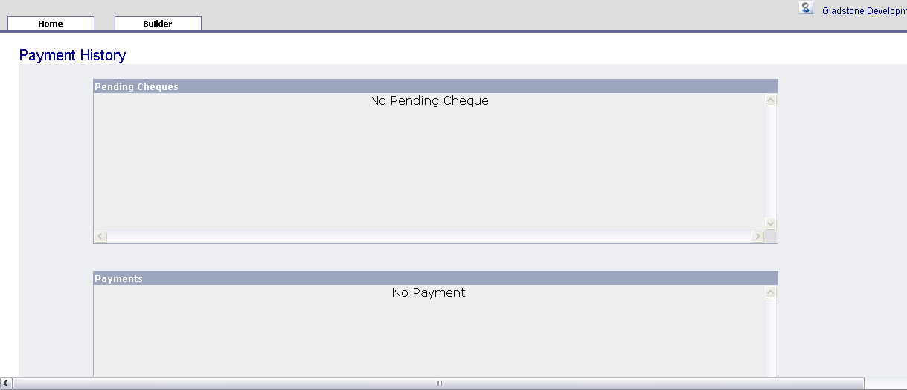

If you have paid some invoices via our system
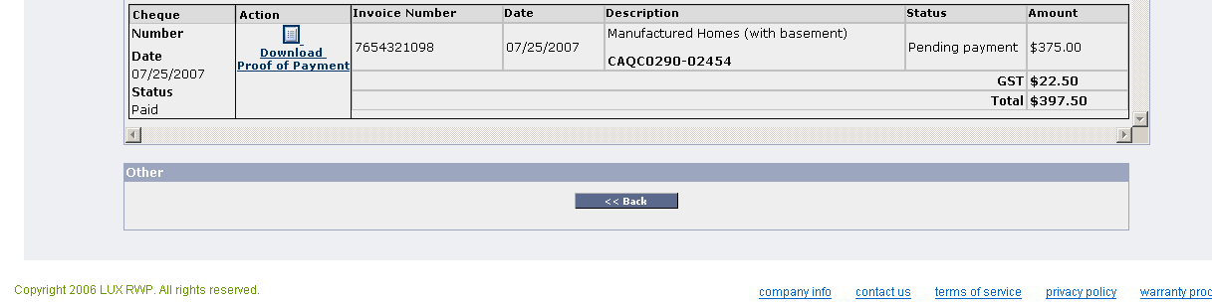

Page detail:

This page contains two panels:

- The first one is for pending cheques

You can see there the cheque payments that you have entered in the system.
These cheque payments stay in this area as long as Lux Residential Warranty Program does not receive a physical cheque by mail.
When the cheques are received the payment goes in the next area.

- The second one is for the validated payments.

The received cheques and card payments are shown here.
You can print proof of payments from each of these payments.

Possible Actions:

- Download Invoice
  - For each payment, in the action column, you can view and print a proof of payment by clicking on the icon.
- Back
  - Brings you back to the Home Page.

Dialogue Board Page

This page is a general purpose communication board.

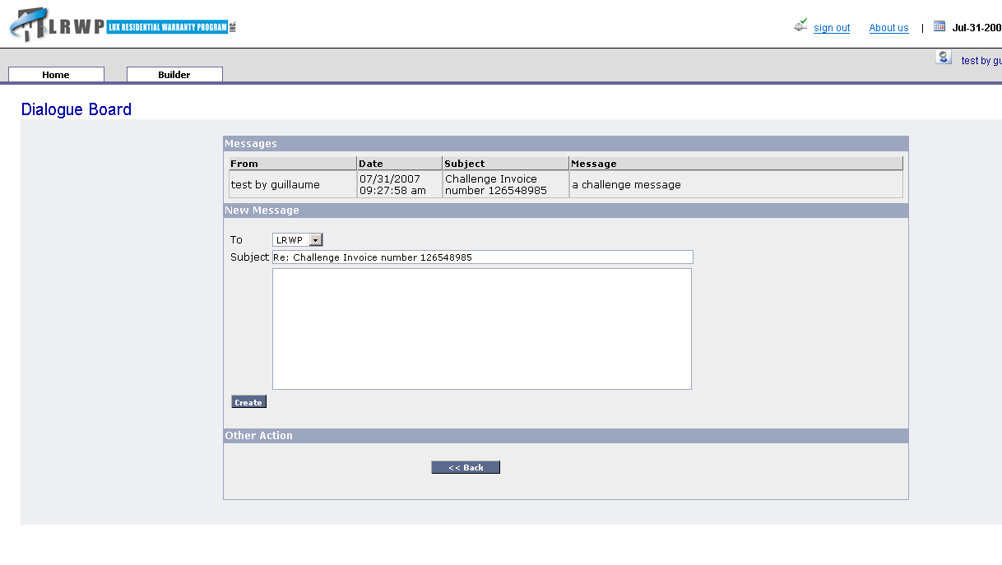
Page detail:

This page shows messages related one to another, aggregated in a “Dialogue”.
This way you can see all the conversations about a given topic: a challenged invoice for example.

Messages panel:

At the top of the page you can the messages list with their author name, date and time and message itself.
Theses messages are displayed with the most recent one at the top.

- From
  - The message author name.
- Date
  - The date when the message was created.
- Subject
  - The message subject
- Message
  - The message text.

New Message panel:

You can use this zone to create a new message:
- To
  - Defines who will receive the message.
- Subject
  - The message subject. When you challenge an invoice you can not change the subject.
- Text area
  - The message text.

Possible Actions:

- Create
  - Creates a new message, only if you specified a text for the message.
- Back
  - Brings you to the previous visited page and does not make any change to the dialogue.

